This is how the images will look….
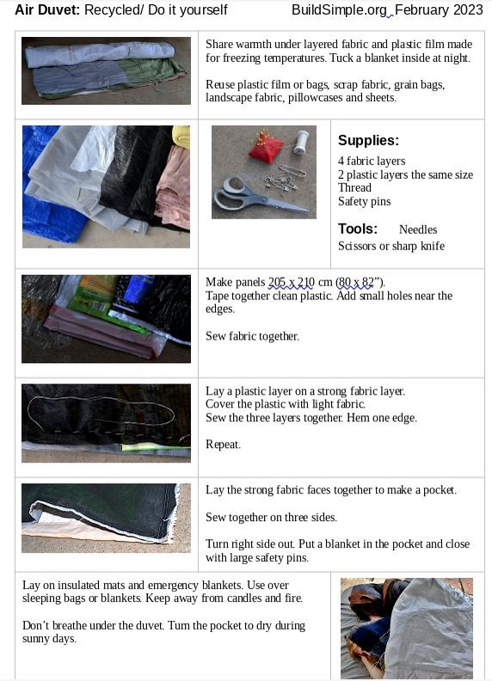

It’s easier if you work in this table without any images.
The hardest part is to use as few words as possible but still be clear! Some languages require longer phrases, and that’s ok.

Air Duvet: Recycled/ Do it yourself BuildSimple.org February 2023

English | Translation
Air Duvet: Recycled/ Do it yourself
Share warmth under layered fabric and plastic film made for freezing temperatures.
Tuck a blanket inside at night.
Reuse plastic film or bags, scrap fabric, grain bags, landscape fabric, pillowcases and sheets.
Supplies:
4 fabric layers
2 plastic layers the same size
Thread
Safety pins
Tools:
Needles
Scissors or sharp knife
Make panels 205 x 210 cm.
Tape together clean plastic.
Add small holes near the edges.
Sew fabric together.
Lay a plastic layer on a strong fabric layer.
Cover the plastic with light fabric.
Sew the three layers together.
Hem one edge.
Repeat.
Lay the strong fabric faces together to make a pocket.
Sew together on three sides.
Turn right side out.
Put a blanket in the pocket and close with large safety pins.
Lay on insulated mats and emergency blankets.
Use over sleeping bags or blankets.
Keep away from candles and fire.
Don’t breathe under the duvet.
Turn the pocket to dry during sunny days.

This is how the images will look….
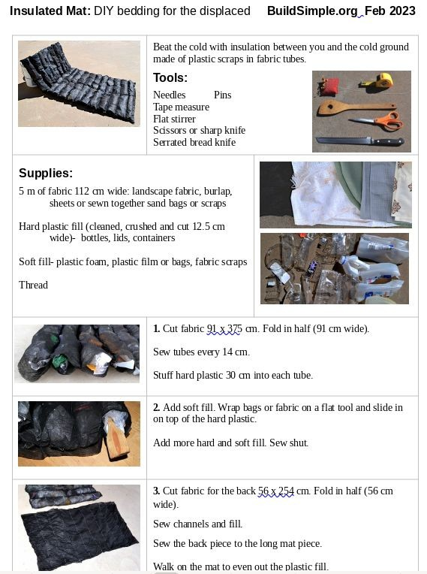

It’s easier if you work in this table without any images.

Insulated Mat: DIY bedding for the displaced BuildSimple.org Feb 2023

English | Translation
Insulated Mat:
DIY bedding for the displaced
Beat the cold with insulation between you and the cold ground made of plastic scraps in fabric tubes.
Tools:
Needles
Pins
Tape measure
Flat stirrer
Scissors or sharp knife
Serrated bread knife
Supplies:
5 m of fabric 112 cm wide: landscape fabric, burlap, sheets or sewn together sand bags or scraps
Hard plastic fill (cleaned, crushed and cut 12.5 cm wide)- bottles, lids, containers
Soft fill- plastic foam, plastic film or bags, fabric scraps
Thread
1. Cut fabric 91 x 375 cm.
Fold in half (91 cm wide).
Sew tubes every 14 cm.
Stuff hard plastic 30 cm into each tube.
2. Add soft fill.
Wrap bags or fabric on a flat tool and slide in on top of the hard plastic.
Add more hard and soft fill.
Sew shut.
3. Cut fabric for the back 56 x 254 cm.
Fold in half (56 cm wide).
Sew channels and fill.
Sew the back piece to the long mat piece.
Walk on the mat to even out the plastic fill.

Lay a plastic film or tarp on the mat under a foam mattress.
Keep away from candles or fire.
Thank you so much for any help!
If either of the documents is more than one page, that will be ok.

